**EE 325: Probability and Random Processes Programming Assignment 3**

**GitHub** repo: [https://github.com/rookie-apoorv/Programming-Assignment-3.git](%20https:/github.com/rookie-apoorv/Programming-Assignment-3.git)

**The Three Systems:**

|  |  |  |  |
| --- | --- | --- | --- |
| **System** | **K** | **pk** | **ak** |
| 1. | 4 | p1 = 0.2,p2 = 0.4, p3 = 0.6, p4 = 0.65 | a1=a2=a3=a4=2 |
| 2. | 4 | p1 = 0.2,p2 = 0.4, p3 = 0.6, p4 = 0.65 | a1=2, a2=a3= 2.5, a4 = 3 |
| 3. | 4 | p1 = 0.2,p2 = 0.4, p3 = 0.6, p4 = 0.65 | a1=8, a2=a3=a4 = 2 |

**Algorithm A**

* We select N1 people, and recommend N1/K people each k type video and observe their behavior.
* For the next N-N1 people we select the best video type from this exploratory phase.
* The best video is taken to be the one with the most number of clicks out of N1/K recommendations.
* We now formulate the probability of choosing the wrong type video after recommending N1 people.
* The correct video type for system 1 is the one which yields the maximum expected revenue.
* The expected revenue is

E(Revenue) =

* This is maximum for video type 4 in system 1
* So
* P( Selecting wrong video type ) = P ( selecting type 1,2,3 after N1 recommendation)
* = 1 – P ( Selecting type 4 video after N1 recommendation)
* = 1 – P(number of clicks of type 4 is greater than number of clicks of 1,2,3)
* As all the above events are independent this probability can be written as, let nk be number of clicks of video type k out of N1/K recommendations
  + 1 - n_4 = i) * P(n_1 < i ) * P (n_2 < i ) * P (n_3 < i)
  + The number of clicks follows binomial distribution with N1/K trials and success probability pk for each k type video.
  + P(n_4 = i) = PMF of binomial distribution at i and P(n_k < i) = CDF of binomial at i.
  + 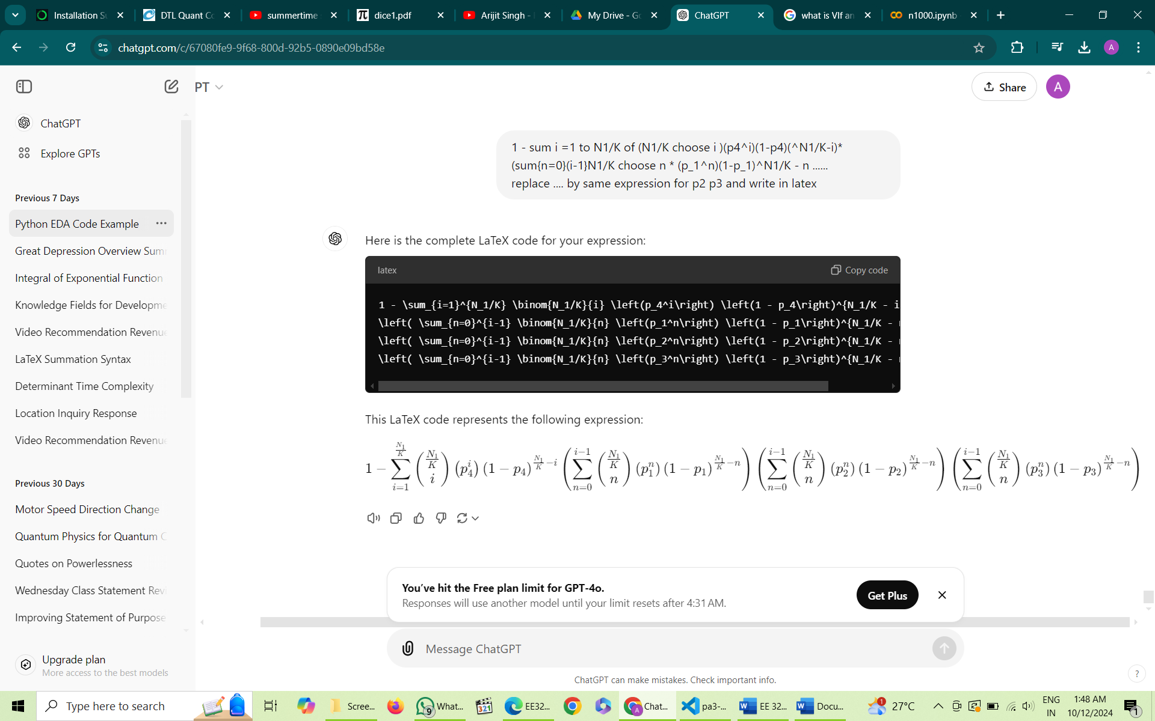Placing values we get

Algorithm B:

Summary of the algorithm :

* For each s from 0 to N, recommend type k video with maximum UCB value at the moment.
* Increment nk for the chosen video type.
* Increment mk with a probability of pk.
* Increment Rk ( Revenue earned from type k videos) randomly any value between 0 and ak if clicked and 0 if not clicked.
* Do this 1000 times, and calculate the avg value of nk, mk and Rk for each value of s.
* Plot the average values for each k as a function of s.

Calculating UCBk:

* Using Hoeffding’s lemma

PLOTS: For N = 10,000

Alpha = 0.1

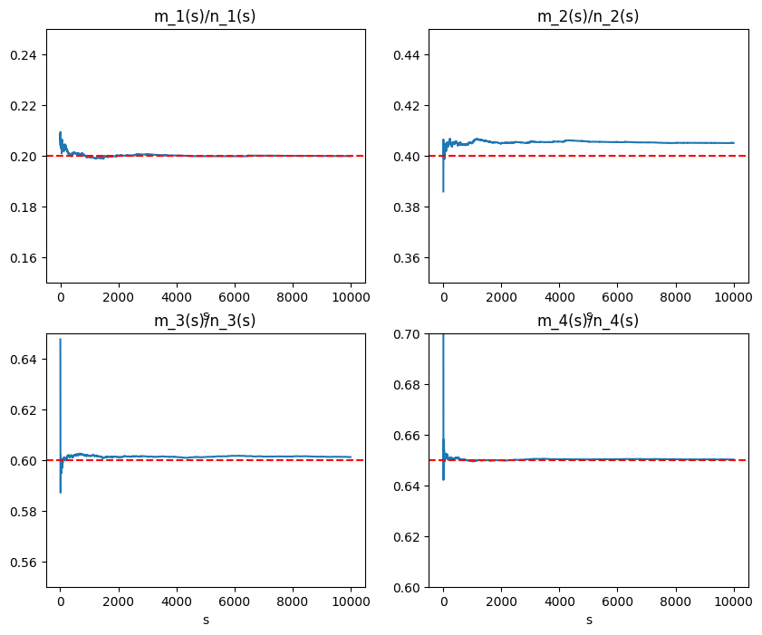

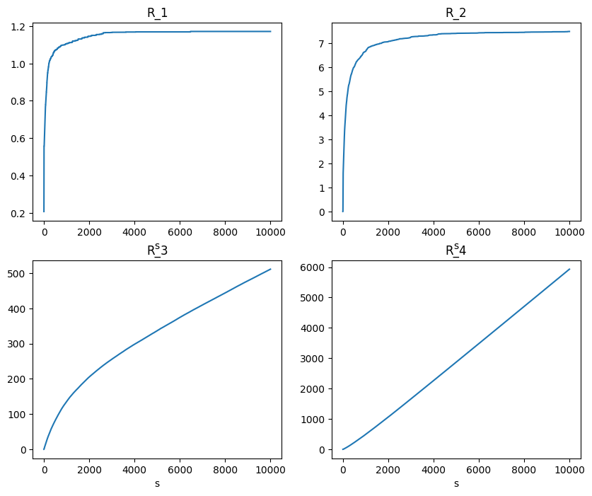

6451.546884852386 = total_revenue after N people

Alpha = 0.05

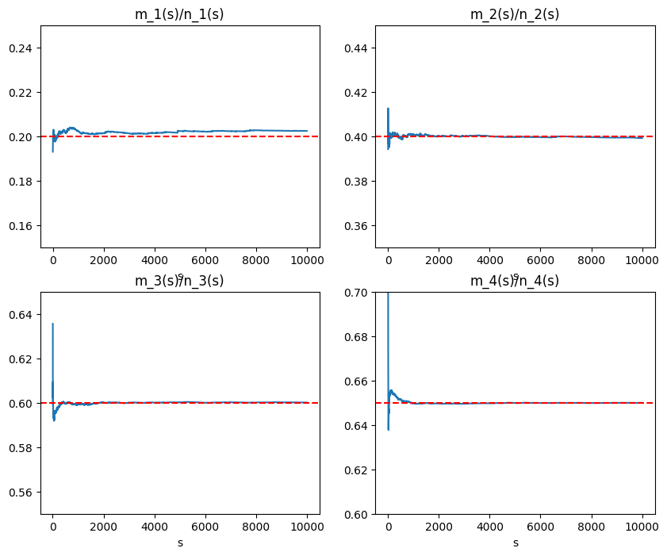

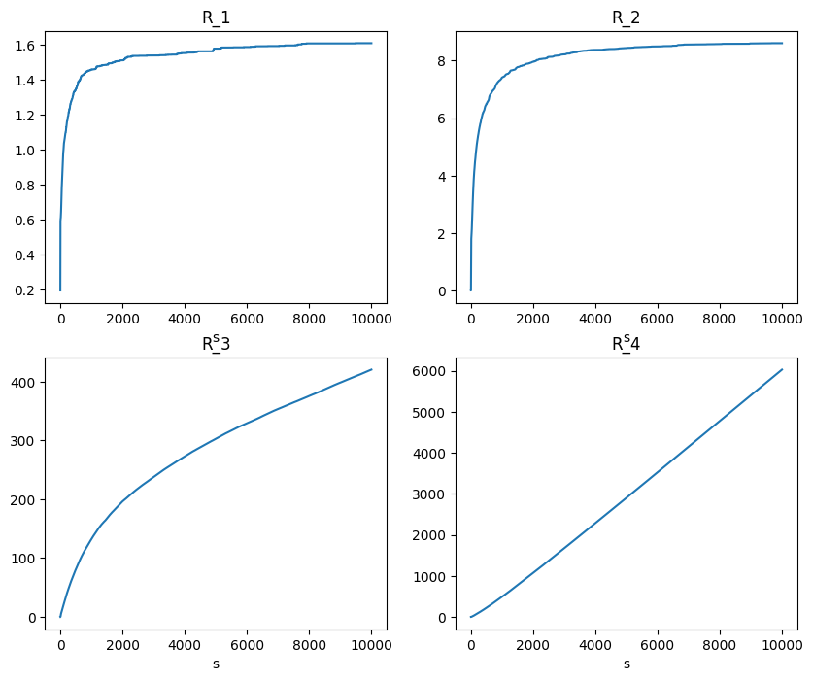

Total_revenue_N_people = 6459.072892797279

Alpha = 0.01

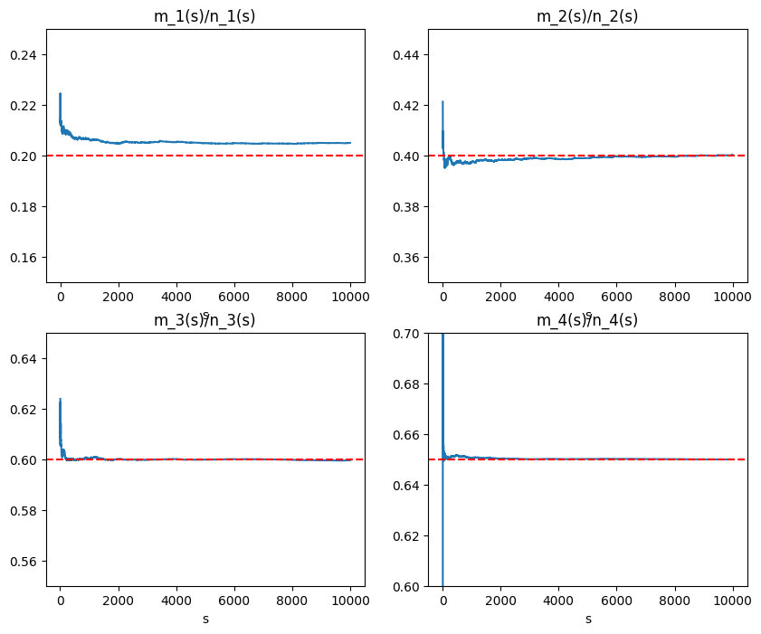

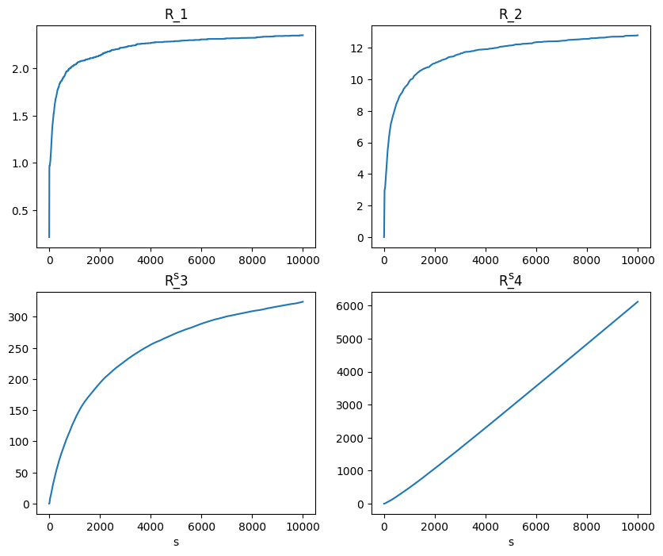

Total_revenue_N_people = 6457.328603952969

For system1: The total revenue for N people turns out to be

|  |  |  |
| --- | --- | --- |
| Alpha | Total Revenue from N people | Best expected value |
| 0.1 | 6451 | 6,500 |
| 0.05 | 6459 | 6,500 |
| 0.01 | 6457 | 6,500 |

* The above gives the sample average of total revenue for 10,000 users for system 1.

Discussion on effects of various parameters:

**Effect of**

* It can be observed that decreasing the value of \alpha and hence decreasing our tolerance for the upper bound improves the algorithm’s performance.
* This can be seen in terms of total revenue rise from \alpha = 0.1 to \alpha = 0.05.
* The R_{k} plot for k = 3 becomes flatter on increasing the value of \alpha.
* This means the algorithm recommends type 3 lesser often for lower values of \alpha and more recommends type 4 hence increasing the revenue.

**Effect of N**

* Increasing the value of N, causes the average revenue to increase, as the algorithm will have more time for using the best value it has discovered for more users hence increasing the revenue.

**Effect of p**

Adapting the algorithm for System 2 and 3

* Algorithm 2 and 3 have different maximum revenue values for different video types.
* This will affect the optimum choice of the video type.
* Till now we have been recommending videos on the basis of UCB which is the upper bound on the values of p.
* The expected revenue for each video recommendation is

E(Revenue) =

* Hence the recommendation should also take into account the revenue collected for a video type for further recommendations.
* For this we have updated the value of UCBk as follows

UCBk  =

* This takes into account the revenue accumulated for a particular video type so far, more the revenue collected, higher the chances of the video to be recommended.
* The following are the plots obtained for system 2 and 3 for the three values of alpha and N=10,000
* System 2:
  + Alpha = 0.1

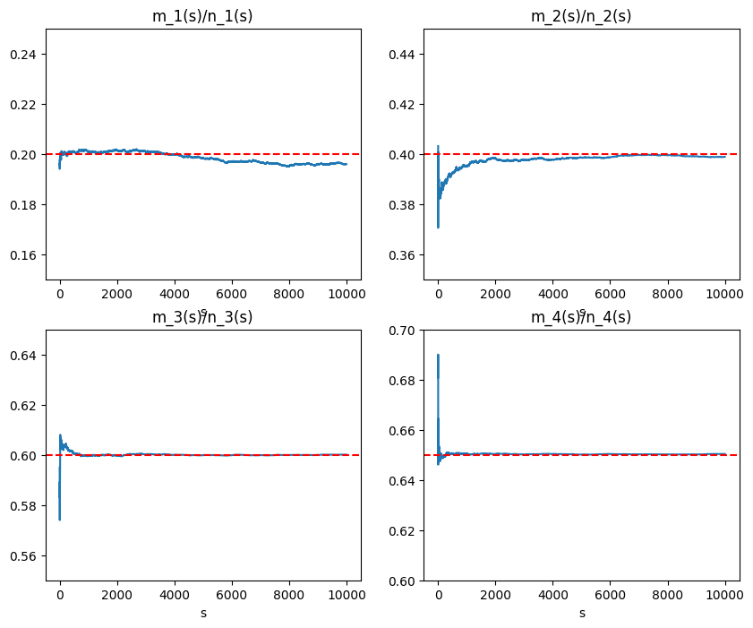

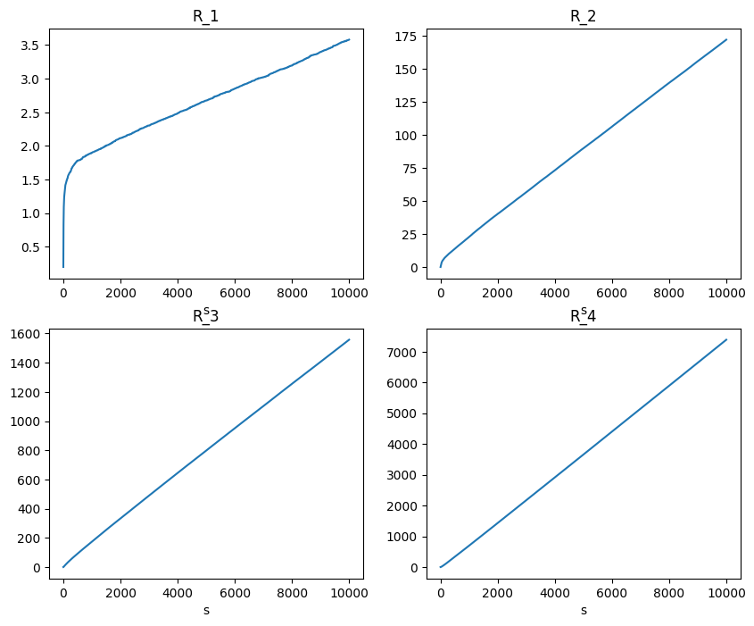

* + Alpha = 0.05

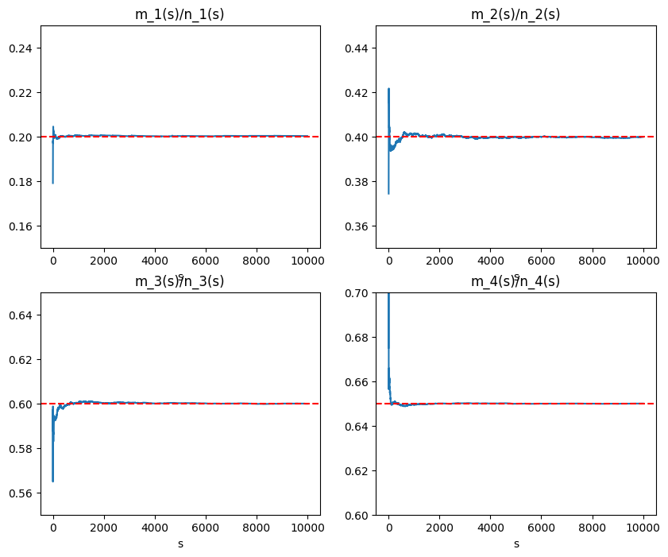

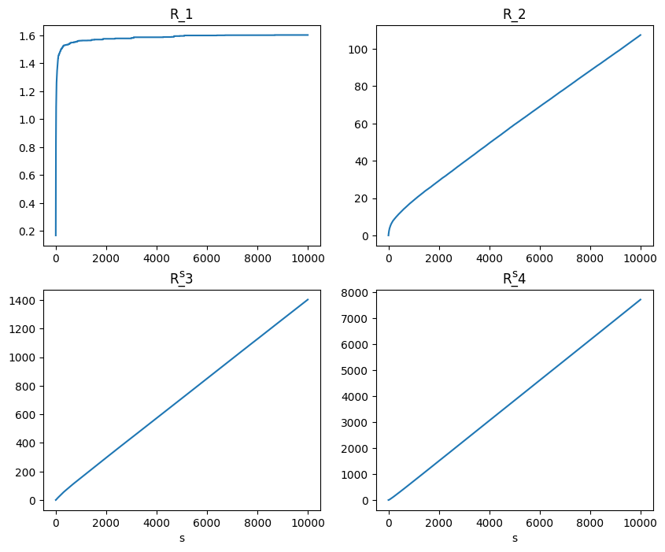

* + Alpha = 0.01

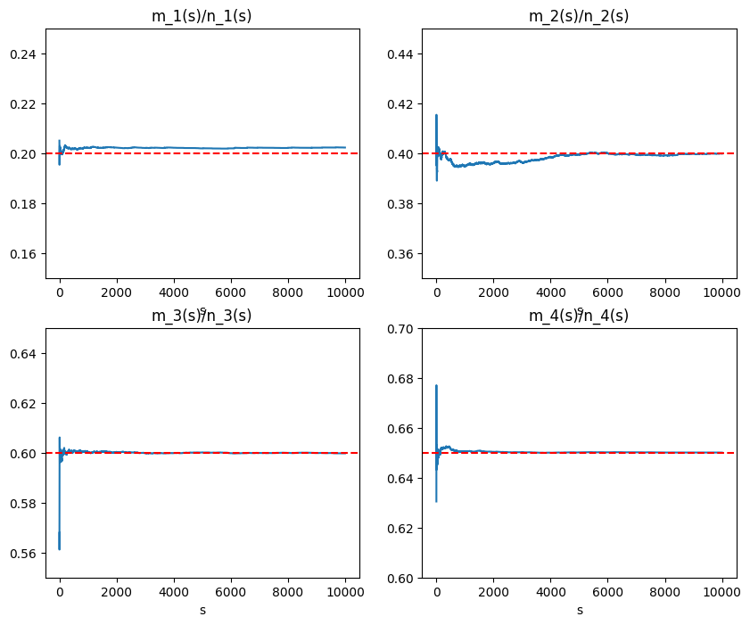

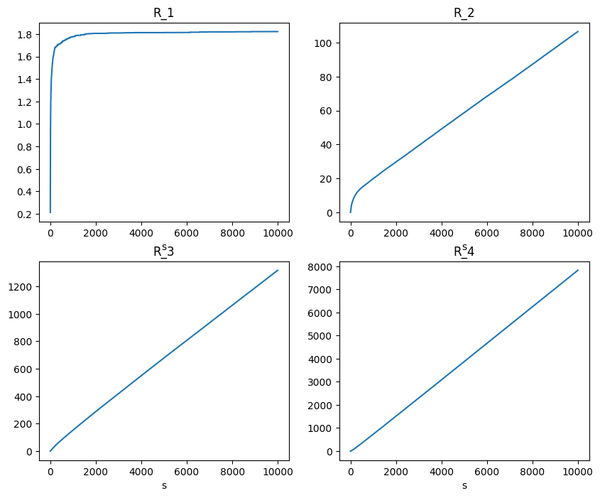

* System 3:
  + Alpha = 0.1

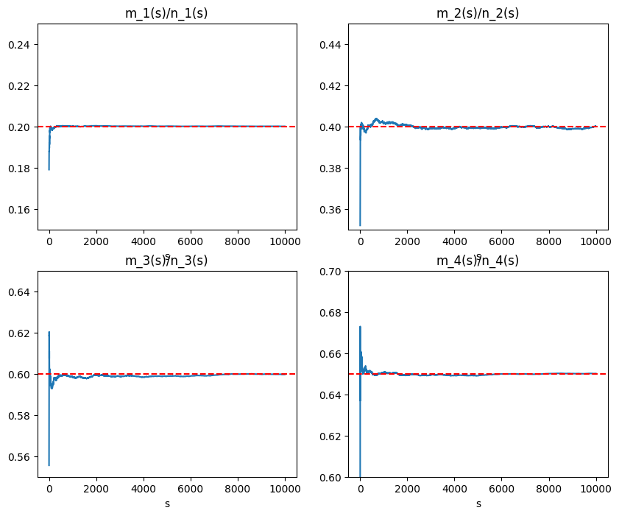

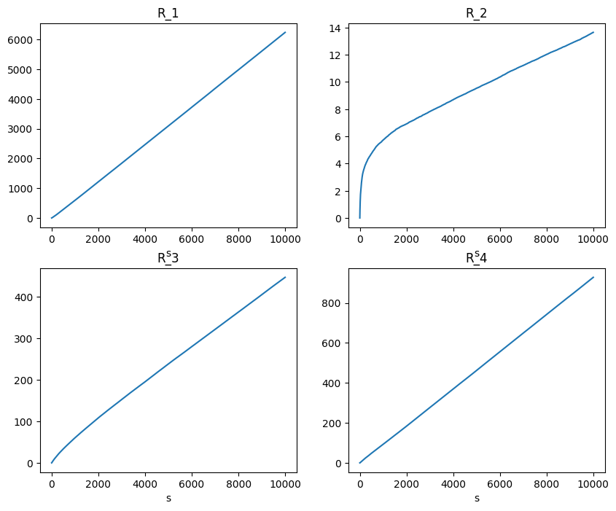

* + Alpha = 0.05

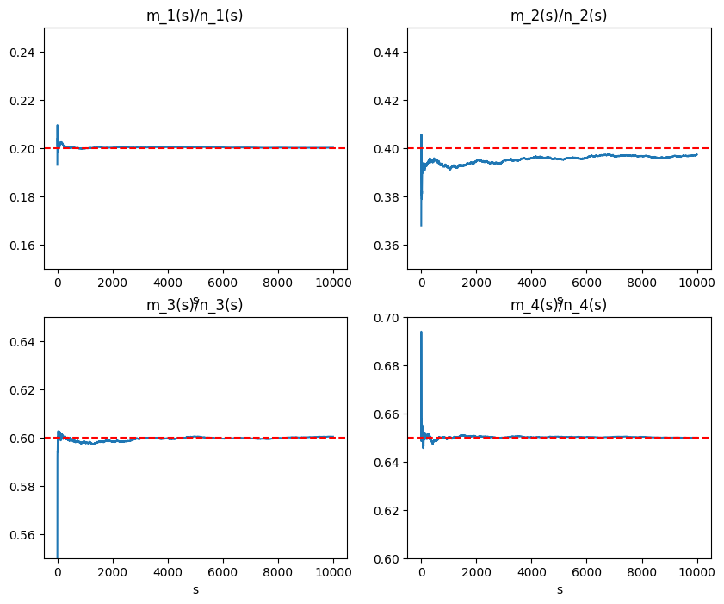

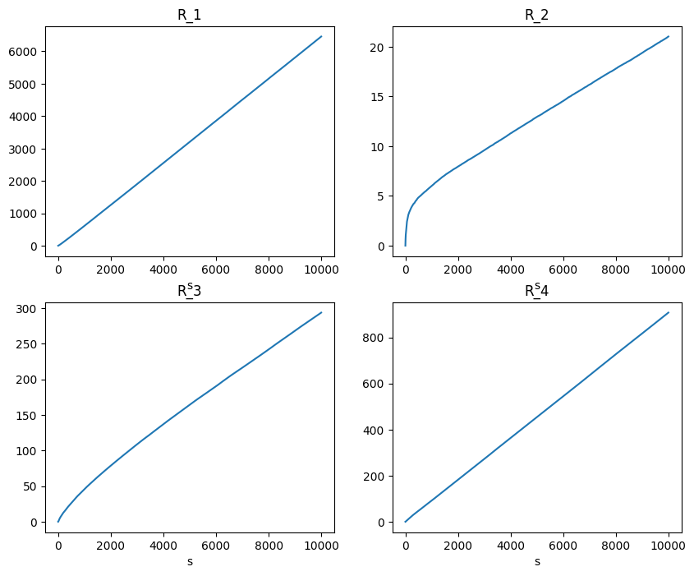

* + Alpha = 0.01

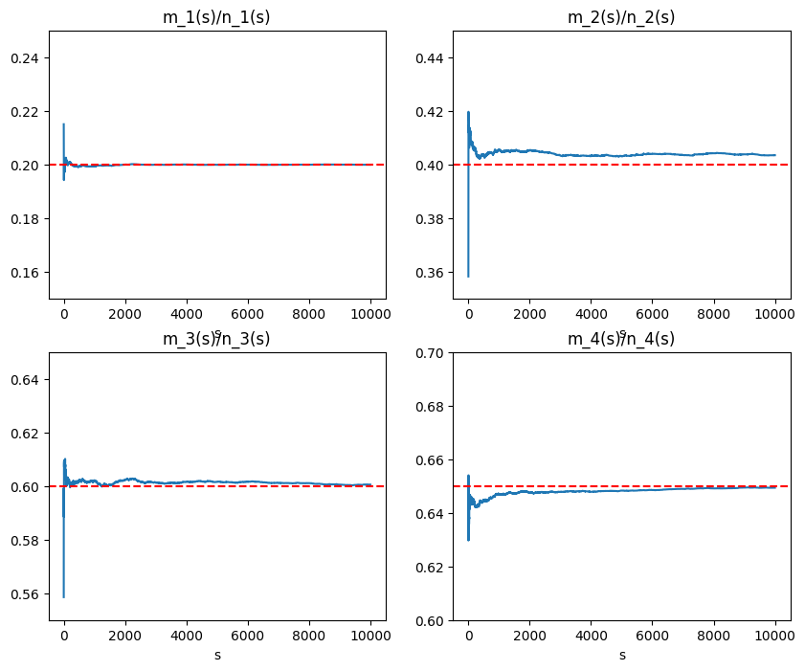

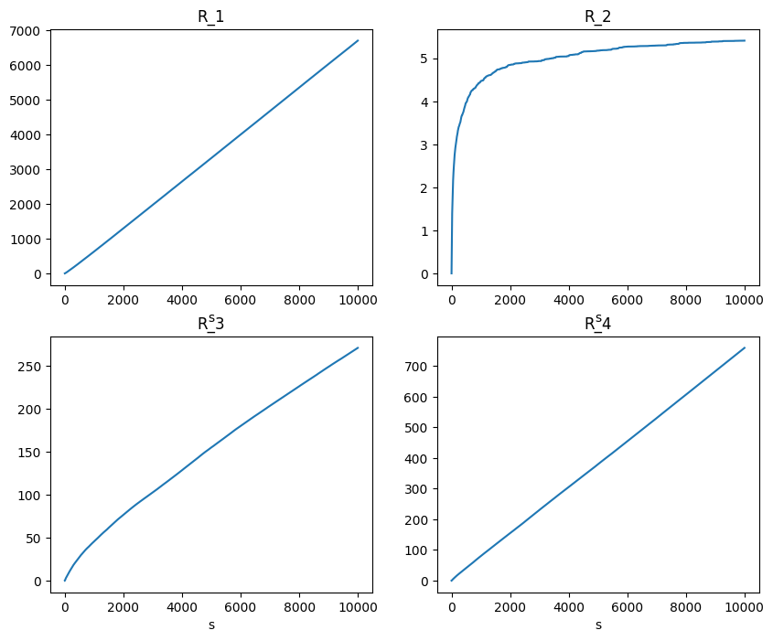

* Values of total revenues for system 2 and 3 at various alpha values
  + System 2

|  |  |  |
| --- | --- | --- |
| Alpha | Total Revenue from N people | Best expected value |
| 0.1 | 9117 | 9,750 |
| 0.05 | 9226 | 9,750 |
| 0.01 | 9257 | 9,750 |

* + System 3:

|  |  |  |
| --- | --- | --- |
| Alpha | Total Revenue from N people | Best expected value |
| 0.1 | 7668 | 8,000 |
| 0.05 | 7678 | 8,000 |
| 0.01 | 7728 | 8,000 |